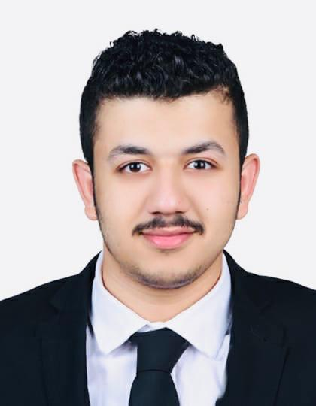

YOUSIF JASSIM ABDULLA

|  |  |  |
| --- | --- | --- |
| Profile*A confident, competent and hard worker. Highly capable of working individually and within teams. Detail-oriented, efficient, and organized professional. Creative and dedicated personality with excellent communication skills.*Education | | |
| 2019 |  | Banking and finance/Accounting (BSc)  *University of Bahrain – Sakheer, Bahrain* |
| 2014  Work Experience |  | High School Diploma  *Ahmed AlOmran Secondary School – Manama, Bahrain*  **Internship**  **CrediMax B.S.C, ’’Fraud Control’’**  *03/2019 – 05/2019* |
| Skills |  | * Strong analytical and problem solving skills. * Excellent written and verbal communication skills. * Highly trustworthy, discreet and ethical. * IT Skills. |
| Languages |  | * English: Fluent * Arabic: Native |
| Personal  Data |  | Full Name: Yousif Jassim Abdulla  Date of Birth: 9 April 1997  Address: House 1887 Road 1559 Saar 515  Status: Single  Contact No: +973 36547545  Email: [yousiif_1997@hotmail.com](mailto:yousiif_1997@hotmail.com) |